**Name: ……………………………………………. ADM NO: …………………………………..**

**Student’s signature: ……………………………. Date: ..…………….…………………………**

**FANAKA GIRLS HIGH SCHOOL**

**DECEMBER HOLYDAY ASSIGNMENT**

**BIOLOGY**

**FORM 2**

**INSTRUCTIONS TO CANDIDATES**

* **Write your name and index number in the spaces provided above.**
* **Answer ALL the questions in the spaces provided in the question paper.**

1. Joy and Lucian, young scientists observed a bird laying her eggs in a nest and later the eggs hatched into chicks. Name three characteristics shown by the chicks that show a chick is a living thing but an egg is not (3mks)
2. Which organelles should be abundant in;
3. Skeletal muscle (1mk)
4. Palisade tissue (1mk)
5. The diagram below represents a plant cell that was subjected to a certain treatment.

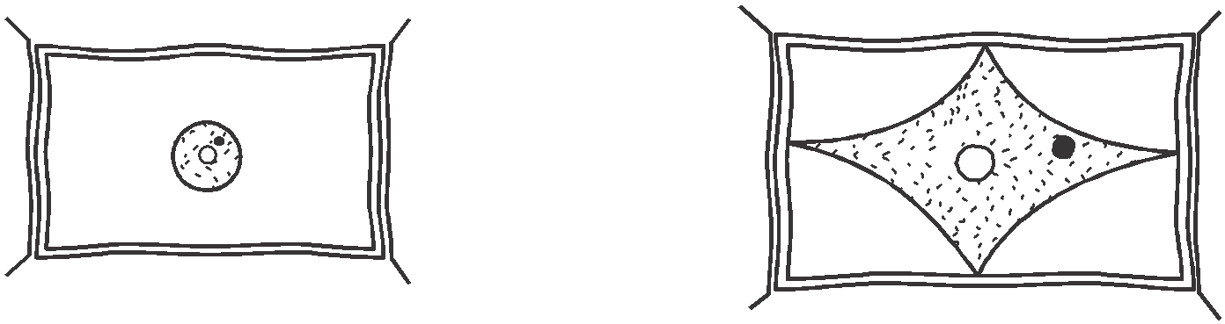

**At the start At the end of the experiment**

1. Account for the shape of the cell at the end of the experiment. (2mks)
2. Draw a diagram to illustrate how an animal cell would appear if subjected to the same treatment.

(1 marks)

1. Give a reason why each of the following steps are followed when preparing cross sections of a leaf for examination under a microscope.
2. Cutting thin sections. (1 mark)
3. Placing the sections in water. (1 mark)
4. Name two tissues in plants that provide mechanical support.
5. Name the gaseous exchange structure in the following organisms.
6. Amoeba (1 mark)
7. Grasshopper (1mark)
8. The diagram below illustrates the structure of a gill from a bony fish.

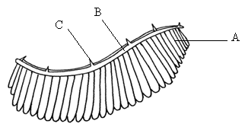

1. Name the parts labelled A, B, C (3 marks)
2. State the function of the part labelled C (1 mark)
3. How is part A adapted to carry its functions (2 marks)
4. A student dropped a small piece of fresh liver in a beaker containing hydrogen peroxide. A lot of fizzling and frothing was observed.
5. a)Name the process 1mk

b) Name the gas produced. [1mk]

c) Write the word equation for the reaction above. [1mk]

10. If the pancreas of an individual malfunction 1mk

a) Name the hormone that is deficient in the animal 1mk

b) What disease is the likely disease the individual would be suffering from 1mk

c) Outline any two functions of Glucagon hormone 2mks

11a) Explain why an athlete pants heavily after sprint race [2mks]

b) What is glycolysis (1 mark)

c)Where in a cell does glycolysis occur. (1 mark)

1. The field of view of a light microscope appeared as shown below in diagram A and the diameter in A was occupied by cells as shown in B.

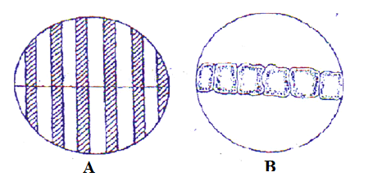

Calculate the length of one cell. (3 marks)

1. The equation below represents a cycle that occurs in the human body.

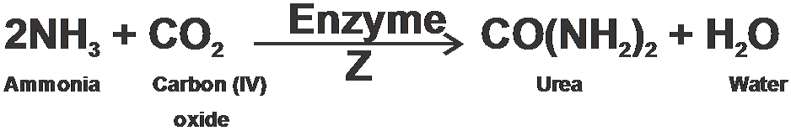

1. identify the above process 1mark
2. In which organ does the process occur? (1 mark)
3. Name enzyme Z (1 mark)
4. Thediagrambelowshowspartofanephronfromthehumankidney.

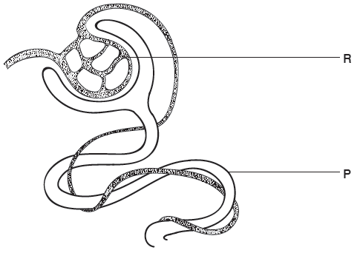

a) (i)Name the structure labeled **R**. (1mark)\

(ii)Nametheprocesscarriedoutat**P** (1mark)

b)The hormone ADH affects water re-absorption from the nephron.

i)Which part of the brain releases ADH? (1mark

ii) Nameapartofthe nephron where water is reabsorbed. (1mark

iii) Name the hormone that acts on the Loop of Henle and give its role 2mks

15. The diagram below represents a transverse section of a plant part. Study it and answer the questions that follow.

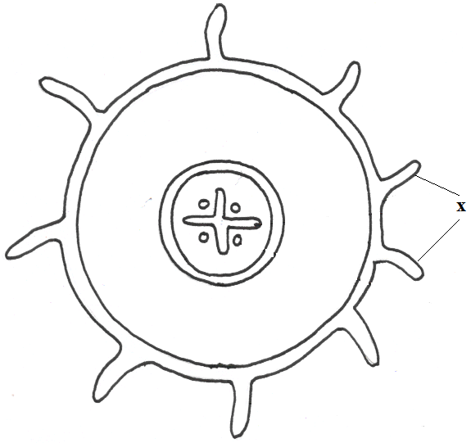

1. Name the class in which the plant belongs. **( 1mark)**
2. Give a reason for answer (a) above **( 1mark)**
3. State **one** adaptation for the structures labeled X to their functions. **(1mark)**
4. Excessive haemorrhage (blood loss) can be rectified through blood transfusion.Complete the table below (2 marks)

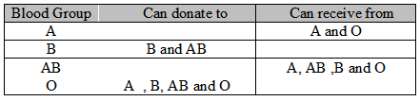

1. Explain the advantage and disadvantage of having blood group O. (2 marks)
2. A person of blood group B marries another person with blood group B. State the possible blood groups of their children. (1 mark)
3. A transfusion of **Rh+ve**blood was given to a patient with **Rh-ve** blood. After one week a similar transfusion was given to the same patient. Explain the likely effect of the second transfusion?(2 marks)

.

**SECTION B**

17. An experiment was earned out to investigate the effect of temperature on the rate of reaction catalyzed by an enzyme. The results are shown in the table below.

|  |  |
| --- | --- |
| Temperature (°C) | Rate of reaction in mg of products per unit time |
| 5 | 0.2 |
| 10 | 0.5 |
| 15 | 0.8 |
| 20 | 1.1 |
| 25 | 1.5 |
| 30 | 2.1 |
| 35 | 3.0 |
| 40 | 3.7 |
| 45 | 3.4 |
| 50 | 2.8 |
| 55 | 2.1 |
| 60 | 1.1 |

 (a) On the grid provided draw a graph of rate of reaction against temperature. (8 marks)

(b) When was the rate of reaction 2.6 mg of product per unit time? (1 marks)

(c) Account for the shape of the graph between

1. 5°C and 40° C (2 marks)
2. 45° C and 60° C (2marks)
3. Other than temperature name two factors affecting enzyme activity (2 marks)
4. (i) Name one digestive enzymes in the human body which works

best in acidic condition. (1 mark)

(ii) How is the acidic condition for the enzyme named in (e) (i) above attained. (1 mark)

1. The acidic conditions in (e) (ii) above is later neutralized
2. Where does the neutralization take place? (1 mark)
3. Name the substance responsible for neutralization. (1 mark

18. a) Briefly describe any four functions of the skin 4mks

b) describe the adaptation of a mammalian skin to its functions 16mks

………………………………………………………………………………………………………………………………………………………………………………………………………………………………………………………………………………………………………………………………………………………………………………………………………………………………………………………………………………………………

………………………………………………………………………………………………………………………………………………………………………………………………………………………………………………

………………………………………………………………………………………………………………………………………………………………………………………………………………………………………………

………………………………………………………………………………………………………………………………………………………………………………………………………………………………………………

………………………………………………………………………………………………………………………………………………………………………………………………………………………………………………

………………………………………………………………………………………………………………………………………………………………………………………………………………………………………………

………………………………………………………………………………………………………………………………………………………………………………………………………………………………………………

………………………………………………………………………………………………………………………………………………………………………………………………………………………………………………

………………………………………………………………………………………………………………………………………………………………………………………………………………………………………………

………………………………………………………………………………………………………………………………………………………………………………………………………………………………………………………………………………………………………………………………………………………………………………………………………………………………………………………………………………………………

………………………………………………………………………………………………………………………………………………………………………………………………………………………………………………

………………………………………………………………………………………………………………………………………………………………………………………………………………………………………………

………………………………………………………………………………………………………………………………………………………………………………………………………………………………………………

………………………………………………………………………………………………………………………………………………………………………………………………………………………………………………

………………………………………………………………………………………………………………………………………………………………………………………………………………………………………………

………………………………………………………………………………………………………………………………………………………………………………………………………………………………………………

………………………………………………………………………………………………………………………………………………………………………………………………………………………………………………